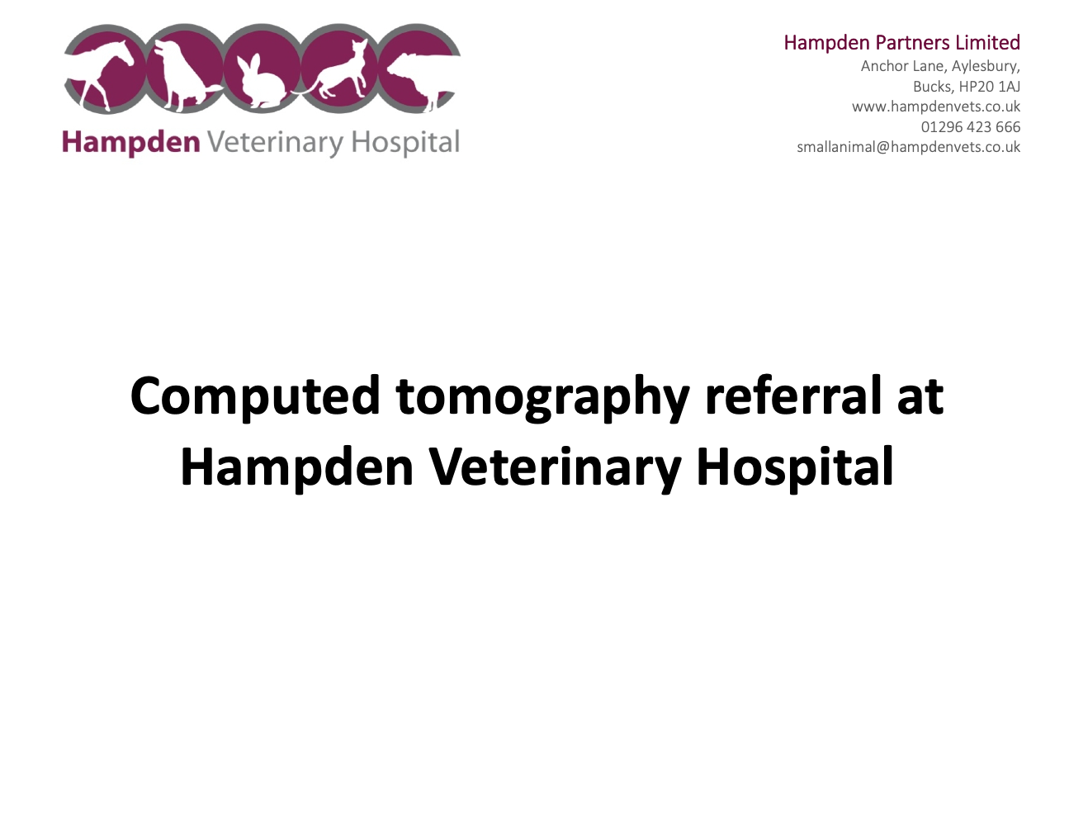

**Computed tomography referral at Hampden Veterinary Hospital**

**Our Computed tomography (CT) referral service**

We are pleased to be able to offer referrals for CT imaging at Hampden Veterinary Hospital. We have several team members who hold certificates in diagnostic imaging, so you can trust that your pet will be in the safest of hands throughout their time with us. If you have any questions about our CT referral service or would like to learn more, please get in touch.

**Hampden Veterinary Hospital**

**Anchor Lane, Aylesbury, HP20 1AJ**

**01296 423 666**

**smallanimal@hampdenvets.co.uk**

**Clinical indications for CT**

* Staging of the neoplastic process (for example, MCT or lymphoma).
* Pyrexia of unknown origin (after initial medical investigation).
* CT as the only practical option:
  + Any metallic implants.
  + Unsafe general anaesthesia.
  + Pacemaker.

1. Head:
   1. Post-trauma.
   2. Any nasal/sinus disease.
   3. Masses/swelling on the head.
   4. Exophthalmos.
   5. Suspicion of sialocele/sialoadenitis.
   6. Ear abnormalities (externa, media +/- inner).
   7. Nasopharyngeal tumours/polyps.
   8. Brain.
      1. Suspicion of macroadenomas in Cushing disease.
      2. Meningioma.
      3. Large intraparenchymal mass compressing other structures.
      4. Hydrocephalus.
      5. Trigeminal nerve sheath tumour (unilateral masticatory muscle atrophy, loss of facial sensation, Horner’s syndrome) – may still need MRI, but may not be any better than CT.
      6. masticatory myositis (MRI and CT are equivalent).
      7. Fascial neuritis is challenging to visualize whether you use CT or MRI but CT is not necessarily worse.

CT is suitable for structures where there is no blood-brain barrier, as there is usually very strong contrast enhancement in these structures. Consequently, it is better to MRI if Chiari-Like malformation or Syringomyelia are suspected.

1. Spine:
   1. Post-trauma.
   2. Discospondylitis.
   3. Lumbosacral disease (may need MRI in very subtle cases).
   4. Invasion of the spine with extraspinal masses (feline injection-site sarcomas (FISS)).
   5. Neoplasia of vertebral column.
   6. Intervertebral disc disease.
      * Hansen type 1 (Acute compressive nucleus pulposus extrusion (ACNPE)).
        + CT is perfect due to the usual mineralisation of the disc in chondrodystrophic breeds.

* Hansen type 2 - Hansen type 2: protrusion = Chronic compressive annulus fibrosus protrusion (CCAFP).
  + - CT might be enough, but sometimes myelography may be required which we do not offer currently.
* Type 3 (Griffith) = explosive disc extrusion = low volume high velocity disc extrusion = Acute non-compressive nucleus pulposus extrusion (ANCNPE).
  + - Only MRI.
* Type 4: discal cyst, hydrated disc extrusion = acute hydrated non- compressive nucleus pulposus extrusion (AHNCNPE).
  + - only MRI.

Neck:

* Any swelling/masses in the neck area.
* Suspicion of foreign body (not consistently detectable).
* Thyroid masses.

Chest:

* Extra thoracic structures –
  + Masses/swellings on the chest.
  + Suspicion of rib/sternal/thoracic muscle growth/ neoplasia.
  + Diaphragmatic rupture/hernia.
* Heart
  + Good at diagnosing persistent right aortic arch (PRAA), but not helpful at persistent duct arteriosus (PDA).
  + Heart base and right atrial mass (Chemodectoma, hemangiosarcoma) - except minuscule sizes.
* Mediastinum:
  + Thymoma.
  + Mass.
  + Megaesophagus.
  + Ectopic thyroid mass.
* Respiratory tract
  + As a part of BOAS investigation.
  + Tracheal (hypoplasia, neoplasia, stenosis, trauma (avulsion)).
  + Bronchitis.
  + Bronchiectasis.
  + Bronchopneumonia.
  + Pneumonia.
  + Bronchial foreign body/masses.
  + Tracheal mass/polyp/ +/-collapse.
  + Parenchymal masses/abscess.
  + Lung lobe torsion.
  + Idiopathic pulmonary fibrosis in West Highland terriers.
  + Diagnosing rounded atelectasis as a secondary sign to chronic pleuritis.
* Pleura
  + An investigation of the primary cause of pyothorax.
  + Unexplainable pleural effusion.
  + Might be helpful in chylothorax investigation but may still need to have MRI (lymphatic ducts are difficult to visualize in CT).
  + Not very good in diagnosing the cause of pneumothorax except secondary to grass awns – usually need thoracotomy to diagnose properly.
  + CT may raise our suspicion of mesothelioma or carcinoma but may need further investigation.

Abdomen:

* CT is helpful mainly in assessing abdominal vasculature
  + Portosystemic shunts*.
  + Invasion of vessels by tumors .
  + (adrenal mass invading the CVC).
* Assessing the extent of masses if not evident on ultrasound.
* Assessment of intrapelvic soft tissue.

Orthopaedic:

* Excellent!
* First line for elbows.
* Very good for complicated carpal, tarsal and acetabular fractures.

* We offer an investigation for PSS in small dogs and cats (<5-10 kg). We may still be able to investigate bigger-sized patients, but please get in touch with us before referral.

**Sedation or General anaesthesia (GA)?**

It depends. Due to very short scanning times, most CT patients are being scanned under sedation.

Most of the patients referred for CT of the head, spine, abdomen, and pelvis will be scanned under sedation.

Orthopaedic scans (especially elbows) will be attempted under heavy sedation. However, some will need to be performed under general anaesthesia due to the need for straight positioning of the area of interest.

The chest will be scanned under GA to enable the induction of apnea by hyperventilation, so intubation is required.

We will also need to induce apnoea if we are investigating a suspected portosystemic shunt, so, as above, general anaesthesia will be required.

**Intravenous Contrast Medium**

Contrast is needed in most scans, unless the problem is bone related. Even in those situations, it is sometimes used to show signs of inflammation/increased vascularisation in the surrounding tissue.

We use non-ionic iohexol (Omnipaque). Severe contrast agent reactions appear to be rare in small animals undergoing CT (for ionic contrast reactions).

* They can manifest as profound hypotension or hypertension with bronchospasm after ionic iodinated contrast administration.
* Systemic reactions are a separate category of contrast agent side effects related to chemotoxicity, and encompass complications such as contrast-induced nephrotoxicity (CIN).

**Price list (May 2024)**

CT scan (without interpretation): £1140 including VAT

*This is a fixed price regardless of the number of areas imaged and includes:*

* *Complete haematology and partial biochemistry.*
* *Anaesthetic/sedation for the duration of the CT only.*

*Please note, if any further procedures/investigations are needed, they will be charged for accordingly along with any additional anaesthetic time.*

Interpretation by VetCT (depending on the number of areas and turnaround time).

* One area
  + Standard - £ 242 (incl. VAT).
  + Enhanced - £ 300.
  + Priority - £ 340.
  + Urgent - £410.
* Each additional body area – + £100
  + If we order thoracic + abdomen it will cost:
    - Standard - £ 342.
    - Enhanced - £ 400.
    - Priority - £ 440.
    - Urgent - £510.
    - If you wish to perform an entire hind leg CT, you will be charged for hip+ stifle+ tarsus, so three areas.

Both (two) legs will be scanned at the same time and sent for interpretation, and it will be priced for three areas.

*For graphic explanation, please refer to VetCT musculoskeletal body areas diagrams, and if you still have any questions, please do not hesitate to contact Hampden Veterinary Hospital on **01296 423 666**.

**Checklist for computed tomography referral**

REFERRING PRACTICE …

NAME AND SURNAME OF REFERRING VETERINARY SURGEON…

NAME AND SURNAME OF PATIENT…

* Male/female…
* Neutered *Yes/No*

SUMMARISED CLINICAL HISTORY (we will include this section in the VetCT referral form) …

CLINICAL QUESTIONS to be answered (we will include this section in the VetCT referral form)…

Have you spoken to Hampden Veterinary Hospital about the referral yet? *Yes/No*

Have you sent **HISTORY** of the patient to Hampden Veterinary Hospital? *Yes/No*

Have you run blood tests within the 24-48 hours prior to referral? (If not, then we may need to do it on the day of the CT) *Yes/No*

Any known heart or renal disease? *Yes/No*

Any anaphylactic reactions in the past? *Yes/No*

Which AREA would you like to scan? (tick the box)

* *Head ☐*
  + *Ear canal including middle and inner ear specifically* ☐
* *Neck* 
  + *Soft tissue neck (swelling/ suspicion of foreign body/ thyroid neoplasia)* ☐
  + *Cervical spine* ☐
* *Chest* ☐
* *Abdomen* ☐
* *Chest + abdomen + pelvis (for neoplasia staging)* ☐
* *Thoracic spine* ☐
* *Lumbar spine* ☐
* *Pelvis +hips* ☐
* *Stifle* ☐
* *Tarsus (hind paw)* ☐
* *Shoulder* ☐
* *Elbow* ☐
* *Carpus (fore paw)* ☐

Turnaround time:

* Standard: 2-4 business days ☐
* Enhanced: 2 business days ☐
* Priority: up to 24 hours ☐
* Urgent: up to 4 hours ☐

Have you informed the owner regarding the following:

* The risks of anesthesia *Yes/No*
* Cost *Yes/No*
* The limitations of CT and the possible need for further investigation?  *Yes/No*

In the case of obvious radiographic abnormality, and where we believe it is in the animal’s best interests, we may offer further testing / procedures whilst the animal is still sedated / under anaesthetic.

For example, if an obvious nasopharyngeal polyp is identified in a cat’s nasopharynx, we may be able to pull out the polyp while the animal is sedated to provide immediate, temporary relief, or if fluid or a mass is found in the chest or abdomen, we may be able to take samples while the animal is still anaesthetised.

This will depend on the complexity of the procedure and the availability of appropriate team members. Please inform us if there are any procedures that you would rather carry out yourselves, if the owner prefers. Please provide an email address to which VetCT will send a report.

Our reception team will email you to confirm the booking. If you do not receive confirmation within 24 hours, please get in touch with us.

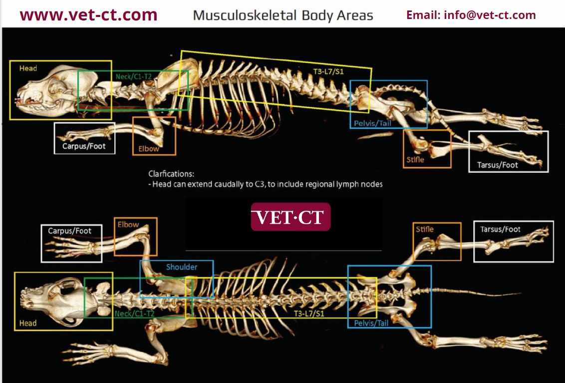

**Flowchart for CT referral:**